

SPECIFICATIONS FOR

Tender 06/2022 - Backup Appliance Warranty Renewal and Expansion

TABLE OF CONTENTS

Advertisement 3
  - General Terms and Conditions 4
  - Format of Response 4
  - Late Submissions 4
  - Applicants to Inform Themselves 4
  - Bidder’s Risk 5
  - Selection of Preferred Applicant 5
  - Conduct of Applicants 5
  - Currency 6
  - Corporate Information 6
  - Qualifications and Capability 6
  - Mergers, Acquisitions, Sales of Applicant 7
  - Enquiries 7
  - Financial Proposal 8
  - Cost Matrix 8
  - Detailed System/Equipment Requirements 10
  - Technical Specifications 10
  - Compliance 10
4.0 Technical Requirements 11
5.0 References 14

Advertisement
The following are excerpts and addendums from the advertisement for Fiji Revenue and Customs Service as it originally appeared in the local media and should be used as the basis to submit your proposals:
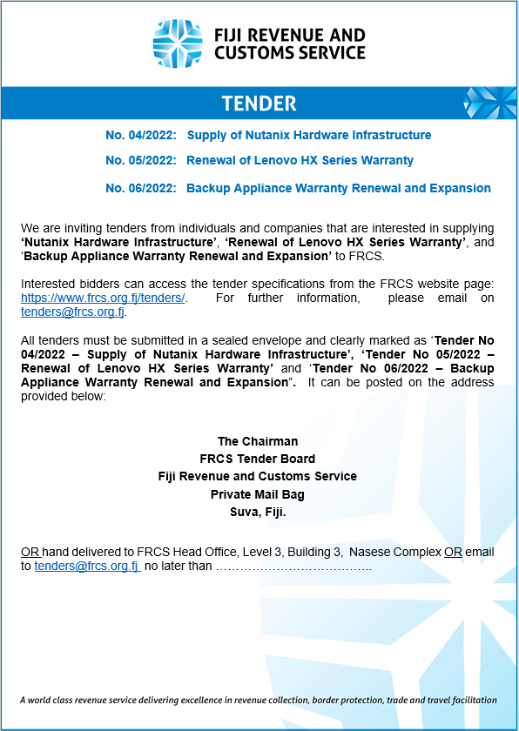

General Terms and Conditions

Following general terms and conditions will apply.

  - Format of Response
Each bidder must provide a formal letter of transmittal that must:
    - Be signed by an authorized representative of the organization and must state that the signing official is authorized to legally bind the organization;
    - Include the names, titles, office addresses and office telephone numbers of the persons authorized by the organization to conduct negotiations on the proposal, including their expected roles in negotiations; and
    - Provide a contact name, address, facsimile number and email address which FRCS will use in serving notices to the bidder.

  - Late Submissions
Submissions received within Five minutes of the closing time will be accepted. Five minutes is allowed as variation for any timing difference.

  - Applicants to Inform Themselves Each applicant should:
    - Examine this specifications document; and any documents referred to within; and any other information made available by FRCS to the applicants;
    - Obtain any further information about the facts, risks and other circumstances relevant to the tender by making all lawful inquiries;
    - Ensure that the submission, and all information on which its proposal is based, is true, accurate and complete.

By submitting their proposal, applicants will be deemed to have:

- Examined the tender specifications and any other information made available in writing by FRCS to the applicants.
- Examined all information relevant to the risks, contingencies, and other circumstances having an effect on their proposal and which is obtainable by the making of reasonable inquiries.

  - Bidder’s Risk
FRCS accepts no responsibility, liability, or obligation whatsoever for costs incurred by or on behalf of any bidder in connection with the EOI or any participation in the tender process.

  - Selection of Preferred Applicant
No proposal will necessarily be selected by FRCS as the preferred solution/s. The FRCS Evaluation Committee may decide not to accept any proposal or reject all proposals at any time. FRCS reserves the right to cancel this tender and pursue an alternative course of action at any time.

Selection of Preferred Applicant will not be acceptance of the proposal and no binding relationship will exist between the preferred applicant(s) and FRCS until a written agreement acceptable by FRCS is executed by an authorized officer of FRCS and the successful applicant(s).

  - Conduct of Applicants
Conduct of Applicants or any of their consortium members, may affect the outcome of their tender responses, including non-consideration of the proposal. Applicants warrant to FRCS that they (and their consortium members) have not and will not engage in any of the following activities in relation to this tender process:
    - Lobbying of or discussions with any politician or political groups during this tender process;
    - Attempts to contact or discuss the tender process with officers, any member or staff or contractor currently working in FRCS or any agent of this Department; Exception to Evaluation Committee members.

    - Provision of gifts or future promise of gifts of any sort to the previously mentioned personnel;
    - Accepting or providing secret commissions;
    - Seeking to influence any decisions of FRCS by an improper means; or otherwise acting in bad faith, fraudulently or improperly.

  - Currency
All currency in the proposal shall be quoted in Fiji Dollars and prices shall be VAT Inclusive.

  - Corporate Information
Each applicant must provide the following information:
    - Details of the corporate and ownership structure, including identification of any holding company or companies and parent companies (Business license and Business Registration);
    - Profiles of the company and any parent entity. If the company is a subsidiary, the applicant must provide full details of the legal and financial relationship between the subsidiary and parent. The names of all directors and officers of the company;
    - A full description of current operations of the company including the most recent audited financial statement;
    - A copy of the company’s Certificate of Incorporation;
    - Confirmation that the company has the capacity to bid for the Services and that there is no restriction under any relevant law to prevent it from bidding;
    - Provision of details of any legal proceedings that are being done against the company.

  - Qualifications and Capability Each Applicant must:
    - Be FNPF, Tax and Customs compliant. Tax Identification Number (TIN) must be quoted in the proposal. (Tax, VAT and FNPF Letters attached to proposal).

    - Be able to demonstrate that it will be able to meet its financial obligations under this tender.
    - The bidder has to have direct partnership with the supplier (Partner Certificate to be included with proposal) and must be an authorised reseller or distributor.

  - Mergers, Acquisitions, Sales of Applicant
Where such information is publicly accessible, the Applicant must indicate whether any mergers, acquisitions or sales are planned presently or during the year following the submission of the proposal.

  - Enquiries
- All questions and enquiries regarding this tender are to be made in writing via email or official letter.
- All questions and inquiries will be responded to in writing by email.
- Verbal responses will not have any binding on either party.

Financial Proposal
  - Cost Matrix

Bidders should provide their cost breakdown in the following format. Costing to be provided for a one(1) and three (3) year term support renewal for the existing solution. A separate breakdown must be included for the Node Expansion per site.
- COST BREAKDOWN SUMMARY FOR CURRENT ENVIRONMENT WARRANTY RENEWAL

COST MATRIX
Category | Description | Cost (FJD)
Products | Hardware/Appliance
Products | 1 Year Hardware & Support (Production)
Products | 1 Year Hardware & Support (DR)
Products | -- add rows as needed
Products | 3 Year Hardware & Support (Production)
Products | 3 Year Hardware & Support (DR)
Products | Software (where applicable)
Products | -- add rows as needed
Products | Total

- COST BREAKDOWN SUMMARY FOR RUBRIK EXPANSION PER SITE (Production & DR)

COST MATRIX
Category | Description | Cost (FJD)
Products | Hardware/Appliance (3 Year Coverage Warranty Appliance and Premium Support)  -2 Node (Production & DR each)
Products | Production Node Hardware Cost
Products | -- add rows as needed
Products | DR Node Hardware Cost
Products | -- add rows as needed
Products | Production & DR Sub-Total
Products | Software/Feature Subscriptions
Products | -- add rows as needed
Products | Software/ Subscription Sub-Total
Products | Accessories (Cables and Transceivers)
Products | - Cables
Products | - Transceivers
Products | -- add rows as needed
Products | Accessories Sub-Total
Products | Solution Grand Total
Products | Rubrik Professional Training and Certification  - Rubrik Administration (4 IT Support Staff Minimum)  - Must include at least 1-2days of walkthrough of new solution support staff onboarding, operational procedures for day-to-day best practice maintenance.
Products | Professional Services  - Installation and As Build Documentation (Inclusive of Trainer Travel/Remote Session and other Expenses applicable)
Products | -- add rows as needed
Products | Professional Services Sub-Total
Products | Overall Solution & Implementation Total

Detailed System/Equipment Requirements
  - Technical Specifications –
    - The tender submission should contain detailed specifications of the proposed solution including supplier contacts for queries and clarifications.

  - Compliance –

Compliance should be
- Full Compliance(FC)
- Partial Compliance(FC)
- Non Compliance(NC)

Reference to documents supporting compliance to be provided.

4.0Technical Requirements
Backup Appliance Warranty Renewal and Expansion– Minimum Requirements
A. EXISTING SOLUTION WARRANTY RENEWAL SPECIFICATION (1 YR & 3 Yr)
TECHNICAL COMPLIANCE MATRIX
Category | Description | Compliance  (FC / PC / NC)
RBK-SVC-PREM-APPLIANCE  (1 YEAR) | Premium Support, Prepaid for Rubrik Appliance  Support Renewal for Rubrik Appliance:  - Device 01 Serial# AA191364040035,  - Device 02 Serial# AA190964040003
RBK-SVC-PREM-APPLIANCE  (3 YEAR) | Premium Support, Prepaid for Rubrik Appliance  Support Renewal for Rubrik Appliance:  - Device 01 Serial# AA191364040035,  - Device 02 Serial# AA190964040003

- RUBRIK PRODUCTION & DR SINGLE NODE EXPANSION (PER SITE)
TECHNICAL EXPANSION SPECIFICATION (3 Year Term Warranty & Support)
 | TECHNICAL COMPLIANCE MATRIX
Category |  | Requirement  (Production & DR) | Compliance  (FC / PC / NC) | Office Reference  (Include Data Sheet, Web URL, Tech Document for requirement verification or relevant information)
RUBRIK APPLIANCE |  | 60TB USEABLE BACKUP STORAGE, INCLUDES  SSD DRIVE AND SFP NIC (3 Yr)
RUBRIK SUBSCRIPTION |  | RUBRIK GO BUSINESS EDITION (3Yr)  - Inclusive of RCDM, Polaris GPS, CloudOn, Polaris Radar, VMs of Cloud Native Protection and Premium Support
 |  | - Premium Support for Hardware Prepay (3Yr)
ACCESSORIES |  | Required Fiber Optic Cables
 |  | Required SFP+ Transceiver

5.0 References

Bidders are required to provide a list of Local and/or International references who are currently using or have used a similar/same solution in the past 12-36 months along with certified technical staff profile for implementation. This should include contact details and designation of the person who is authorised to provide a reference on behalf of the Company.

Terms & conditions may vary and will depend on the assessment undertaken by FRCS. When making a submission, bidders must submit two (2) hard copies with one marked “original” and the other marked “copy” and one (1) soft copy emailed to tenders@frcs.org.fj or presented to FRCS via a secured USB drive. All clarifications can be directed via email to tenders@frcs.org.fj.
A completed and signed copy of the Compliance Criteria Form together with all pertaining documents must also be included with the submission.

END

