

SPECIFICATIONS FOR

Tender 05/2022 – Renewal of Lenovo HX Series Warranty

TABLE OF CONTENTS

Advertisement 3
  - General Terms and Conditions 4
  - Format of Response 4
  - Late Submissions 4
  - Applicants to Inform Themselves 4
  - Bidder’s Risk 5
  - Selection of Preferred Applicant 5
  - Conduct of Applicants 5
  - Currency 6
  - Corporate Information 6
  - Qualifications and Capability 6
  - Mergers, Acquisitions, Sales of Applicant 7
  - Enquiries 7
  - Financial Proposal 8
  - Cost Matrix 8
  - Detailed System/Equipment Requirements 10
  - Technical Specifications 10
  - Compliance 10
4.0 Technical Requirements 11
5.0 References 14

Advertisement
The following are excerpts and addendums from the advertisement for Fiji Revenue and Customs Service as it originally appeared in the local media and should be used as the basis to submit your proposals:
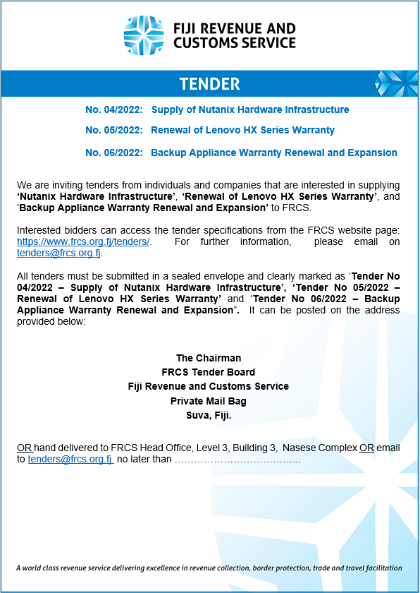

General Terms and Conditions

Following general terms and conditions will apply.

  - Format of Response
Each bidder must provide a formal letter of transmittal that must:
    - Be signed by an authorized representative of the organization and must state that the signing official is authorized to legally bind the organization;
    - Include the names, titles, office addresses and office telephone numbers of the persons authorized by the organization to conduct negotiations on the proposal, including their expected roles in negotiations; and
    - Provide a contact name, address, facsimile number and email address which FRCS will use in serving notices to the bidder.

  - Late Submissions
Submissions received within Five minutes of the closing time will be accepted. Five minutes is allowed as variation for any timing difference.

  - Applicants to Inform Themselves Each applicant should:
    - Examine this specifications document; and any documents referred to within; and any other information made available by FRCS to the applicants;
    - Obtain any further information about the facts, risks and other circumstances relevant to the tender by making all lawful inquiries;
    - Ensure that the submission, and all information on which its proposal is based, is true, accurate and complete.

By submitting their proposal, applicants will be deemed to have:

- Examined the tender specifications and any other information made available in writing by FRCS to the applicants.
- Examined all information relevant to the risks, contingencies, and other circumstances having an effect on their proposal and which is obtainable by the making of reasonable inquiries.

  - Bidder’s Risk
FRCS accepts no responsibility, liability, or obligation whatsoever for costs incurred by or on behalf of any bidder in connection with the EOI or any participation in the tender process.

  - Selection of Preferred Applicant
No proposal will necessarily be selected by FRCS as the preferred solution/s. The FRCS Evaluation Committee may decide not to accept any proposal or reject all proposals at any time. FRCS reserves the right to cancel this tender and pursue an alternative course of action at any time.

Selection of Preferred Applicant will not be acceptance of the proposal and no binding relationship will exist between the preferred applicant(s) and FRCS until a written agreement acceptable by FRCS is executed by an authorized officer of FRCS and the successful applicant(s).

  - Conduct of Applicants
Conduct of Applicants or any of their consortium members, may affect the outcome of their tender responses, including non-consideration of the proposal. Applicants warrant to FRCS that they (and their consortium members) have not and will not engage in any of the following activities in relation to this tender process:
    - Lobbying of or discussions with any politician or political groups during this tender process;
    - Attempts to contact or discuss the tender process with officers, any member or staff or contractor currently working in FRCS or any agent of this Department; Exception to Evaluation Committee members.

    - Provision of gifts or future promise of gifts of any sort to the previously mentioned personnel;
    - Accepting or providing secret commissions;
    - Seeking to influence any decisions of FRCS by an improper means; or otherwise acting in bad faith, fraudulently or improperly.

  - Currency
All currency in the proposal shall be quoted in Fiji Dollars and prices shall be VAT Inclusive.

  - Corporate Information
Each applicant must provide the following information:
    - Details of the corporate and ownership structure, including identification of any holding company or companies and parent companies (Business license and Business Registration);
    - Profiles of the company and any parent entity. If the company is a subsidiary, the applicant must provide full details of the legal and financial relationship between the subsidiary and parent. The names of all directors and officers of the company;
    - A full description of current operations of the company including the most recent audited financial statement;
    - A copy of the company’s Certificate of Incorporation;
    - Confirmation that the company has the capacity to bid for the Services and that there is no restriction under any relevant law to prevent it from bidding;
    - Provision of details of any legal proceedings that are being done against the company.

  - Qualifications and Capability Each Applicant must:
    - Be FNPF, Tax and Customs compliant. Tax Identification Number (TIN) must be quoted in the proposal. (Tax, VAT and FNPF Letters attached to proposal).

    - Be able to demonstrate that it will be able to meet its financial obligations under this tender.
    - The bidder has to have direct partnership with the supplier (Partner Certificate to be included with proposal) and must be an authorised reseller or distributor.

  - Mergers, Acquisitions, Sales of Applicant
Where such information is publicly accessible, the Applicant must indicate whether any mergers, acquisitions or sales are planned presently or during the year following the submission of the proposal.

  - Enquiries
- All questions and enquiries regarding this tender are to be made in writing via email or official letter.
- All questions and inquiries will be responded to in writing by email.
- Verbal responses will not have any binding on either party.

Financial Proposal
  - Cost Matrix

Bidders should provide their cost breakdown in the following format. Costing to be provided for three (3) year term support renewal for the existing solution. A separate cost breakdown must be included on per site basis
- COST BREAKDOWN SUMMARY FOR PRODUCTION SITE

COST MATRIX
Category | Description | Cost (FJD)
Products | Hardware/Appliance (3 Year Coverage)
Products | 3 Year Hardware & Support (Prod & DR)
Products | -- add rows as needed
Products | Software (where applicable for 3 Yr Term)
Products | -- add rows as needed
Products | PRODUCTION RENEWAL TOTAL

- COST BREAKDOWN SUMMARY FOR DR SITE

COST MATRIX
Category | Description | Cost (FJD)
Products | Hardware/Appliance (3 Year Coverage)
Products | 3 Year Hardware & Support (Prod & DR)
Products | -- add rows as needed
Products | Software (where applicable for 3 Yr Term)
Products | -- add rows as needed
Products | DR RENEWAL TOTAL

- COST BREAKDOWN SUMMARY FOR QA/DEVELOPMENT SITE
COST MATRIX
Category | Description | Cost (FJD)
Products | Hardware/Appliance (3 Year Coverage)
Products | 3 Year Hardware & Support (QA/Dev)
Products | -- add rows as needed
Products | Software (where applicable for 3 Yr Term)
Products | -- add rows as needed
Products | QA/DEVELOPMENT RENEWAL TOTAL

Detailed System/Equipment Requirements
  - Technical Specifications –
    - The tender submission should contain detailed specifications of the proposed solution including supplier contacts for queries and clarifications.

  - Compliance –

Compliance should be
- Full Compliance(FC)
- Partial Compliance(FC)
- Non Compliance(NC)

Reference to documents supporting compliance to be provided.

4.0 Technical Requirements
Lenovo Hardware Warranty Renewal – Technical Reference Requirements
A. EXISTING SOLUTION WARRANTY RENEWAL SPECIFICATION (3 Year Term)
TECHNICAL COMPLIANCE MATRIX
Category | Requirement | Compliance  (FC / PC / NC)
PRODUCTION SITE | HX SERIES SERIAL TAG (5 Node)  J300TRK3, J300TRK4, J300TRK5,  J300TRK7, J300TRK6
PRODUCTION SITE | SR SERIES SERIAL TAG (6 Servers)  J300TTWA, J300TRH3, J300TN75  J300TRFD, J300T4H2, J300T4H3
DR SITE | HX SERIES SERIAL TAG (3 Node)  J300TNGB, J300TNGC, J300TNGD
DR SITE | SR SERIES SERIAL TAG (3 Servers)  J300TRH4, J300TN74, J300T4H4
QA/DEVELOPMENT | HX SERIES SERIAL TAG (3 Node)  J33LN9P, J33LN9R, J33LN9T
QA/DEVELOPMENT | D1224 SERIAL TAG (3 Node)  J33LG6B, J33LG6C, J33LG6D
QA/DEVELOPMENT | X3850 x6  J33LG8L, J33LG8M, J33LG8N, J33LG8P

5.0 References

Bidders are required to provide a list of Local and/or International references who are currently using or have used a similar/same solution in the past 12-36 months along with certified technical staff profile for implementation. This should include contact details and designation of the person who is authorised to provide a reference on behalf of the Company.

Terms & conditions may vary and will depend on the assessment undertaken by FRCS. When making a submission, bidders must submit two (2) hard copies with one marked “original” and the other marked “copy” and one (1) soft copy emailed to tenders@frcs.org.fj or presented to FRCS via a secured USB drive. All clarifications can be directed via email to tenders@frcs.org.fj.
A completed and signed copy of the Compliance Criteria Form together with all pertaining documents must also be included with the submission.

END

